BLOGPOST - Understanding the rules of the game

Understanding the rules of the game
While in startup-land rules are meant to be broken more often than not, when it comes to the (early stage) fundraising process most founders and investors seem aligned on a few basics outlined in more detail below:
The valuation is typically 3–4x of how much you are looking to raise
Round sizes tend to increase by ~5x between each financing round
The amount of the financing should provide ~15 months runway

1) Funding round amount x 3 = valuation?
The average early stage equity round will dilute the existing shares in your company by approximately 20–25%; unless your company has extremely favourable momentum (stellar growth or usage metrics), you can assume that the combined group of investors at Seed, Series A or B stage will likely expect around 20-25% ownership after the round is complete.
Therefore the amount you are looking to raise indirectly drives your valuation by factor 3 or 4; e.g. if you are pitching to investors to raise $1m, investors are likely to expect something like a $3–4m pre-money valuation ($1m is 25% of the $4m post-money valuation, or 20% of $5m).
This of course is just the starting point for deal term negotiations, but the round size can be considered an initial proposal for the valuation of the round towards your prospective investors. It’s also worth keeping in mind that in the scenario above the final pre-money valuation might actually be even lower if additional shares need to be added to the employee option pool.

2) Raise ~5x more than your previous round
For both founders and investors alike, there is an implicit assumption that the valuation of their startup will rapidly increase from round to round typically leading to increasingly larger amounts raised in each round. However, due to the lack of publicly available early stage startup valuation data, just how much that increase should be is less clear.
In an attempt to quantify the expectations, in the below I looked at a total of 36 financing events including reported size and date of each round of these eight more or less randomly selected startups with between three and seven fundings each: EyeEm, Farfetch, FundingCircle, Soundcloud, Transferwise, Uber, Wunderlist, Zendesk.
Keeping in mind that my analysis is rather anecdotal than scientific in nature, the typical increase in round size vs the last round averages out across all funding rounds of each company at ~5x, i.e. if your previous round was $500k, the following one will be expected to total ~$2.5m.

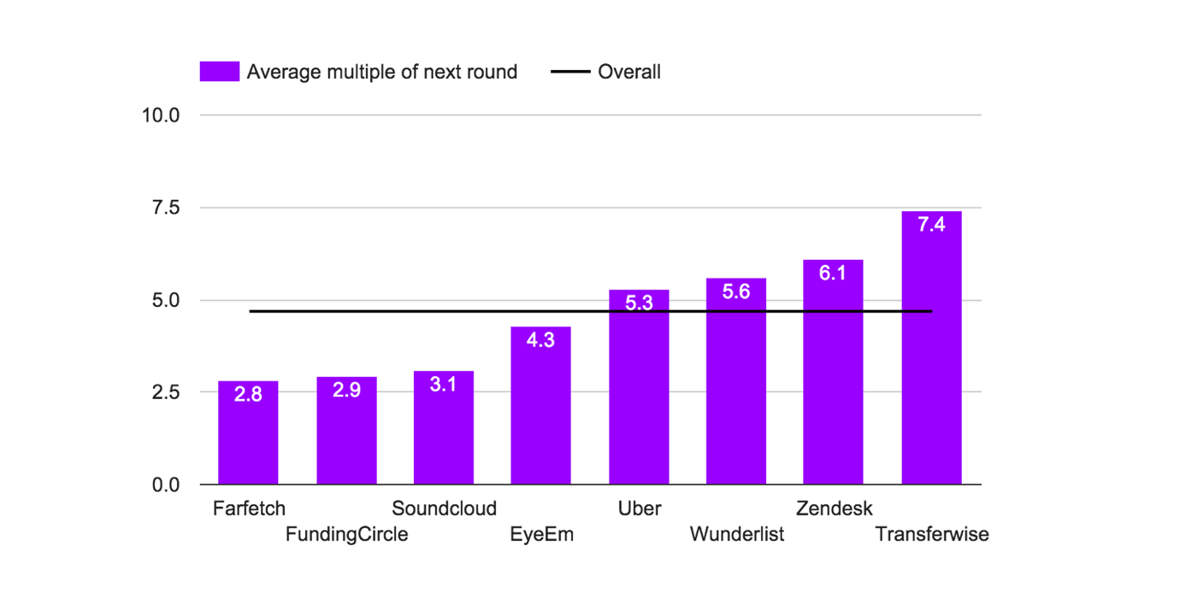

Source: AngelList/Crunchbase
Now let’s review the growth of round sizes by stage of the company: it starts of at ~7x from first institutional cheque into the company (Angel or early Seed) to the next round (typically late Seed or Series A), round indicating that especially the 2nd financing round is often a larger step from the previous one compared to later stage rounds.

So as you are developing your story on how much you want to raise, make sure your plan falls roughly within the perimeters of 3x to 7x, or otherwise potential investors might ask a lot of questions (“why is the company not ambitious enough?”, “they cannot have come so far since that last round?”) or pass on your company without even taking a closer look.

3) You need to have more than 15 months runway in the bank
Standard fundraising rounds take a few months from initial coffee meetings to “money hitting your bank account”, so the common consensus is that one should ideally only raise money every 1–2 years to remain as focussed as possible on building and selling the product.
The average time between funding rounds seems to be ~16 months according to my analysis using the same data set as for point 2.

Source: AngelList/Crunchbase
When comparing the time it takes to raise the next round by the stage of the business, it seems that only at the later stages funding cycles start to accelerate (after round 5 the number reduces to 10 months but is omitted here due to the smaller sample size of only 3 companies in the above selection):

Source: AngelList/Crunchbase
When estimating the amount required to run the company for the next 12–18 months, make sure to carefully reflect the expected growth in expenses, especially team size and salaries (which often need to be lifted to better reflect market rates after a fundraising event) in your cash burn model. This forecast should include both expected revenue as well as expected costs and the resulting cumulative net losses then sum up to the amount raised.

Other influencing factors: location and time?
Additionally to the above constraints, when communicating your valuation and round-size expectations the below data points should be helpful as additional guidance.
AngelList has put together a little tool to get key takeaways from their rich database of Seed round valuation information (unfortunately one cannot drill down any further), but for the two more actionable dimensions I have extracted the data into the following charts.
Northern California clearly dominates the average Seed round valuations with ~$5m on average, while in Europe raising at $3–3.5m is more commonly the case:

Source: AngelList (https://angel.co/valuations)
Contrary to my own impression however timing seems irrelevant, with Seed round valuations not really having changed much since 2010:

Source: AngelList (https://angel.co/valuations)

How to bring it all together into a compelling story?
As most venture backed startups end up raising several rounds of financing, I usually advise founders to think of their current fundraising round as one of several phases in the company growth journey, where the amount raised in a given round is essentially the fuel required to sprint to the next milestone.
Whatever you are looking to raise now should be just enough to get your company to the metrics required to unlock the next phase, i.e. convince investors who typically only invest at later rounds to finance your startup.
Once you had a few informal chats with these investors to get a sense of what they are typically looking for (“$X in monthly recurring revenues”, “X% month-on-month growth rate”, “Xm downloads or unique visitors”, etc), you should be able to quantify roughly how much fuel, such as money, team and other resources you need to realistically hit those milestones.
Other sources of information to quantify later stage investors’ expectations are other VC funded startups’ pitch decks. Alexander Jarvis has put together an excellent selection of these here.
Map out your company’s journey in distinct phases
As you are trying to get investors excited about your company’s journey it is often useful to not only talk about your current round and where you want to get with it, but also put it into perspective of the previous and following phase.

Schiphol airport runway — their longest is 3.8km long
You ideally show this by communicating how you took your previous (angel, seed, A) round and hit all the milestones agreed with your earlier investors. Then you can explain how the amount of the current round will help you reach the next stage for your company, at which you plan to raise additional funds from later stage investors (whose expectations you are clear on and are realistically working towards).
If the number put forward to potential investors is additionally roughly in line with the constraints detailed in the earlier part of this post, this should lead to some interesting conversations.

Other interesting links to check out:
Mark Suster of Upfront Ventures
http://www.bothsidesofthetable.com/2011/10/14/understanding-how-dilution-affects-you-at-a-startup/
Leo Polovets of Susa Ventures
http://codingvc.com/an-algorithm-for-seed-round-valuations
Jordan Cooper of Lerer Ventures
https://jordancooper.wordpress.com/2011/01/12/seed-stage-valuation-guide/
Babak Nivi of AngelList
http://venturehacks.com/articles/seed-valuation

Aus <https://medium.com/entrepreneur-toolkit/how-much-should-your-startup-raise-and-at-what-valuation-d15df45cfcf5#.2f553qlj1>

